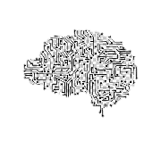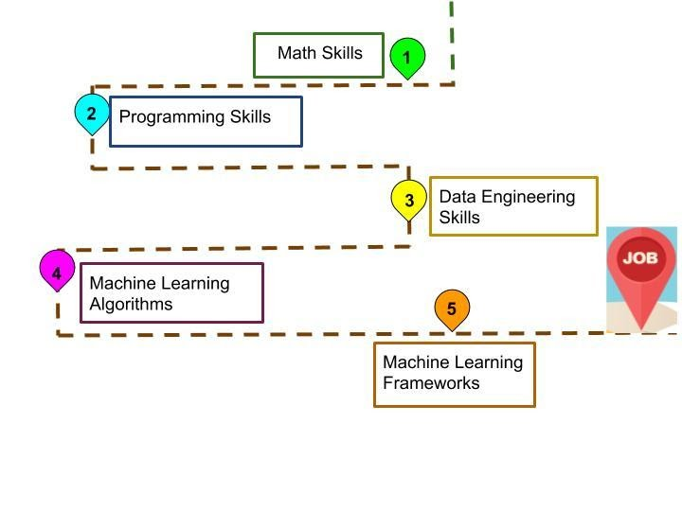

[**Tesla**](https://www.cnbc.com/quotes/TSLA)

boss [**Elon Musk** s](https://www.cnbc.com/elon-musk/)ays [AI is more dangerous than North Korea](https://www.cnbc.com/2017/08/11/elon-musk-issues-a-stark-warning-about-a-i-calls-it-a-bigger-threat-than-north-korea.html).

**Sunder Pichai** spoke about AI and Machine Learning. “Deep learning and AI techniques have been around for many years. But there wasn’t much computational power to run these algorithms. For instance,

**Google Translate** uses **machine learning** which has phenomenally improved the translation prowess,”

**[Google](https://www.business-standard.com/article/technology/google-betting-big-on-ai-machine-learning-sundar-pichai-117010500486_1.html)** [betting big on AI and Machine learning,](https://www.business-standard.com/article/technology/google-betting-big-on-ai-machine-learning-sundar-pichai-117010500486_1.html)

**Apple, Google, Amazon, Netflix, Boston Dynamics, Tesla, IBM kinda large tech companies are working on AI and ML and believe that it’s the Future.**

This **Blog** Just gonna click you up to start on ML platform by **yourself,**

**A lot students gets confused which career to chose as IT field is an ocean like it never ends! As I was in that situation like seeing all tutorials and finding a right choice and decision to start and develop on machine learning,**

Being a noob in Computer Science seeing this blog, It’ll make to you to think righteous on your career path, Every thing should start from basic to pro,

1. Some suggestion as a beginner in ML to be a **ML engineer**, First you need to figure out why and what are you looking for in Machine Learning.

**Machine Learning :**

**Machine learning is a branch of**[**artificial intelligence (AI)**](https://www.ibm.com/cloud/learn/what-is-artificial-intelligence)**and computer science which focuses on the use of data and algorithms to imitate the way that humans learn, gradually improving its accuracy.**

## 

## Machine Learning Services for SaaS - Supervised Learning**Why is machine learning important?**

## Resurging interest in machine learning is due to the same factors that have made [**data mining**](https://www.sas.com/en_in/insights/analytics/data-mining.html) and Bayesian analysis more popular than ever. Things like growing volumes and varieties of available data, computational processing that is cheaper and more powerful, and affordable data storage. All of these things mean it's possible to quickly and automatically produce models that can analyse bigger, more complex data and deliver faster, more accurate results – even on a very large scale. And by building precise models, an organization has a better chance of identifying profitable opportunities – or avoiding unknown risks.

**Steps-1:**

Firstly know about the abc’s of the machine learning like linear algebra, statistics and probability,, and python as **python** as it leads “tech world “, as it has lot of built-in-libraries and some tutorials like “freecodecamp, MIT open courseware materials or Khan Academy etc..”.

Machine Learning need lot of math concepts and data manipulation. So revise some math concepts too.

**Step-2 :**

Also knowing mathematical strategies, We should know a appropriate way to execute and implement it to make useful, Mainly in python we have lot of famous libraries especially for this,

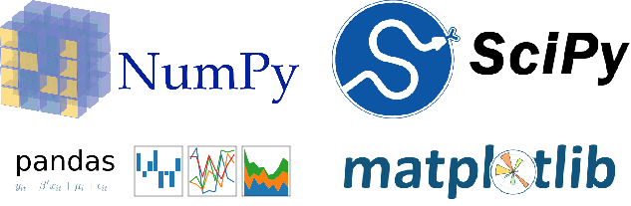

They are:

1. Numpy
2. Pandas
3. Scikit-learn
4. Tensorflow
5. Pytorch etc….

In this the widely used library is **scikit-learn** and **tensorflow** but to get accustomed to it we have start as a beginner using **Numpy,** Pandas So that we know how the algorithm actually works. It’s a right way to get in to coding for ML.

**Step-3:**

**Try some assignments on Machine learning and know the type of problems.**

|  |  |
| --- | --- |
| **Type of ML Problem** | **Description** |
| Regression | Predict numerical values |
| Clustering | Group similar examples |
| Association rule learning | Infer likely association patterns in data |
| Structured output | Create complex output |

These are the typical structure of ML so that any actual problem gets accommodated within these types.

Some optimization Algorithms to learn with

* Gradient Descent
* Linear Regression
* Logistic Regression
* Decision Tree
* SVM etc..

**Practicing problems using these algorithms is very useful and try with some basic projects found in websites like Kaggle, Hackerrank etc…**

**Step-4:**



You are almost ready to unleash yourself to the world as a machine learning pro, Here is the important thing that most of us miss is to do projects, building real world project model gives you the actual experience of how the ML use-cases and try to even improve the knowledge on the depth of ML. Then test your knowledge by creating useful new projects that’ll will be very much helpful in your cv while placements and improve skills.

**Time period to master ML for a college student**:

On an average if you spend around atleast 3-4 hours a day is enough so that it gets on as a practice to work the above complete workflow to get along the ML, try to persist your time to follow these steps will take time according how you take in yourself to complete this workflow. Never rush your self for a deadline as it’s a up level concept , make every concepts clear to you and work on daily basis to be a pro . Being a pro is not like knowing everything related to ML as its upcoming platform new features and libraries and algorithms, optimization techniques etc.. this workflow gives you to know what the ML does to the future and if you really want get into it , get into jobs(FAANG) and explore the future.

ALL THE BEST FOR FUTURE CAREER!!